Figma

https://www.figma.com/design/xkLQuSzxbJ04JBXSRHZaKI/Figma-basics?node-id=1669-162202&node-type=canvas&t=32EaFaFHiWvChi5j-0

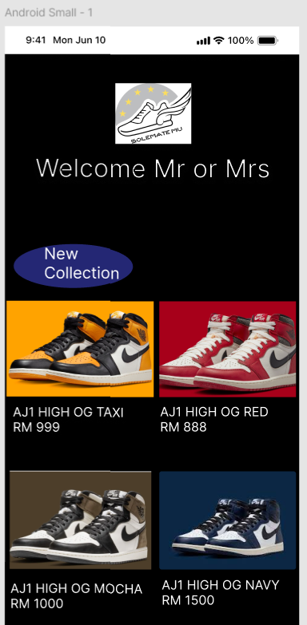

Figure 1: The main page of the mobile app

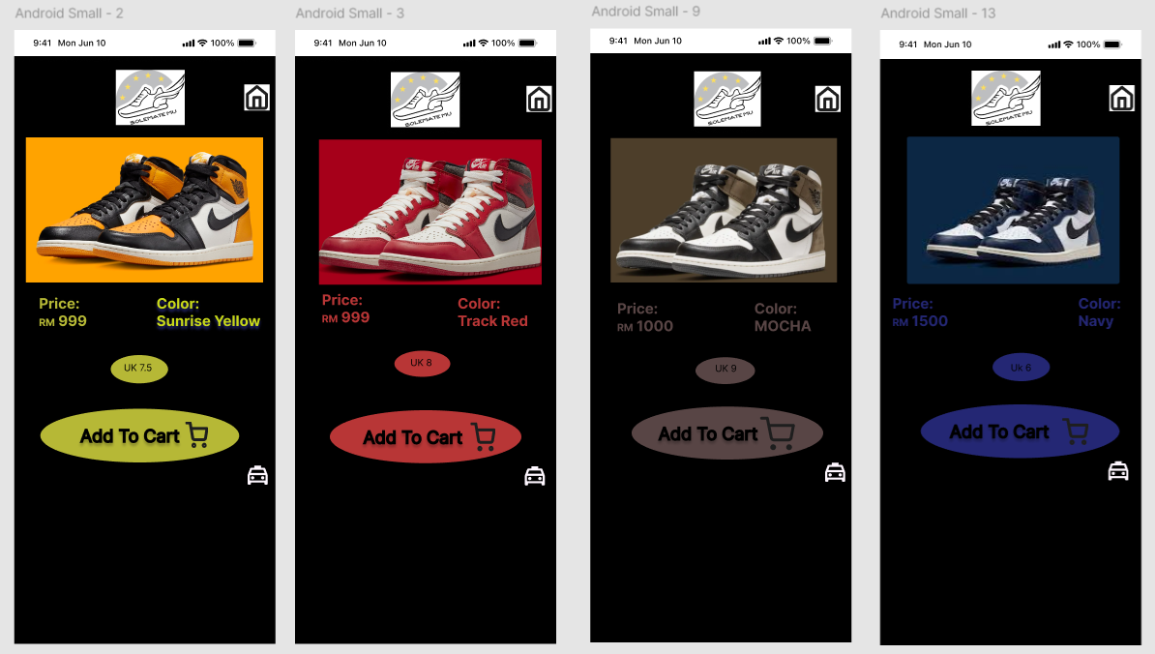

Figure 2: The product page will be show when user click on each of the product in the main page to view

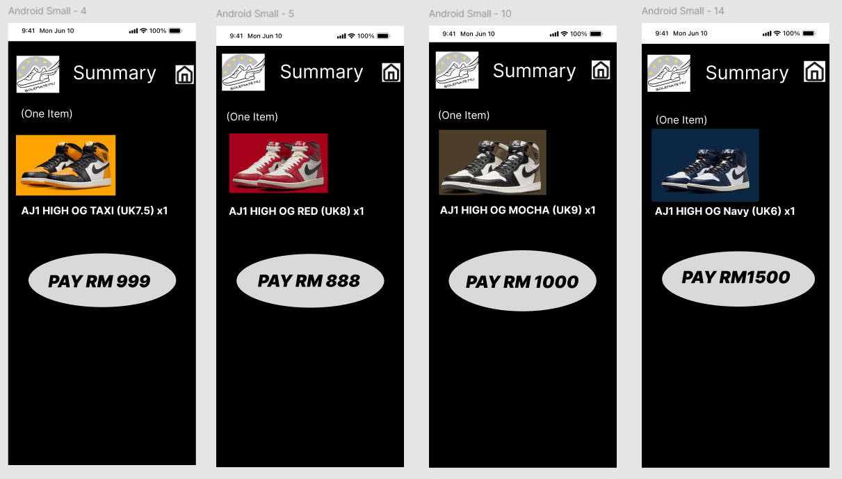

Figure 3: The amount of each product will be show when user click on add to cart

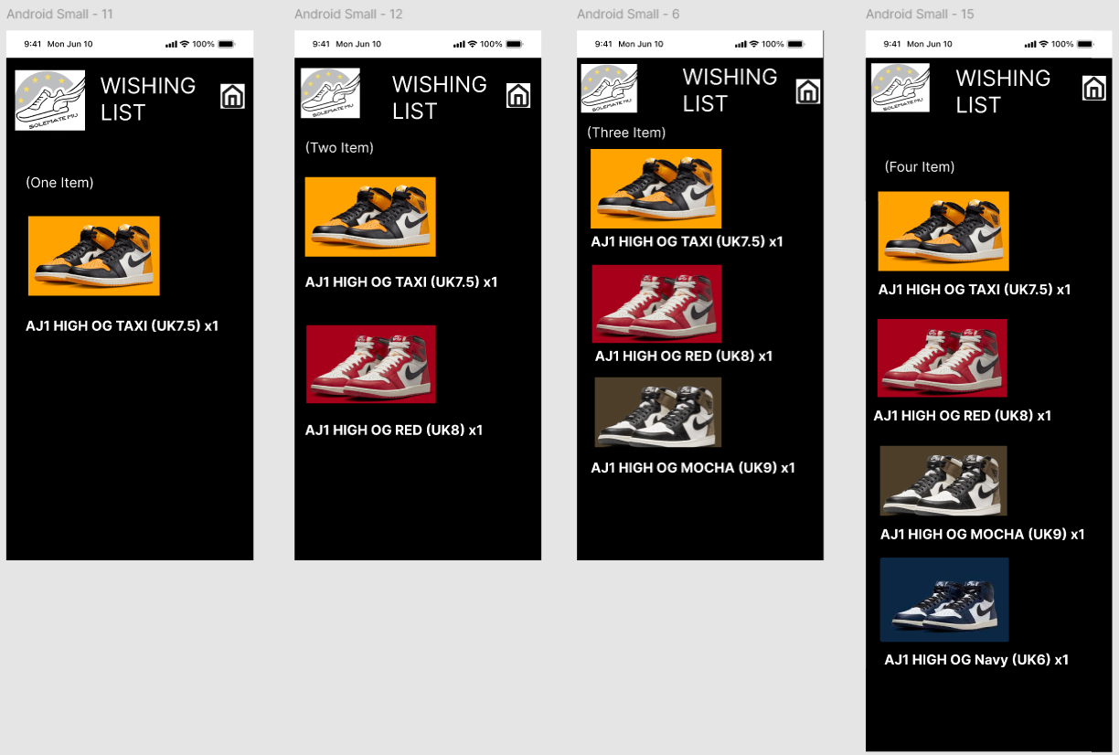

Figure 4: The wishing list of the user when click on the taxi symbol

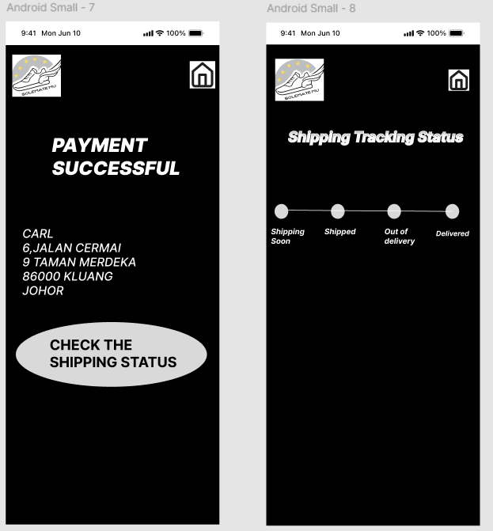

Figure 5: The payment successful and the shipping tracking status when user purchase the sneakers